Test Plan

DIFF tool

Prepared by:

Abdullah Ezzat Abdelsatter   
25/02/2023

TABLE OF CONTENTS

1.0 INTRODUCTION……………………………………….…………………………………………………….2

2.0 PROGRAM FLOWCHART…………………………………………………………………………………3

3.0 Testing Strategy …………………………………………………………………………………………….4

3.1 Alpha Testing (Unit Testing)

3.1.1 OpenFile  
3.1.2 CloseFile  
3.1.3 GotoLine  
3.1.4 CompFiles

3.2 System and Integration Testing

1.0 INTRODUCTION

DIFF tool is an easy and straightforward command line tool that takes two text files as input and provides the similarities and differences between the two files.

The tool takes a line from the first text file and searches for a match in the second text file, so we have three cases:

The line exists in both input files: the line will be printed and colored with white and an equal symbol “=” is added before it.

The line is only in the first file or the line is modified in the second file by adding or removing or modifying one character or more: the line will be printed and colored with red and a minus symbol “-” is added before it.

The line is only in the second file or the line is modified in the first file by adding or removing or modifying one character or more: the line will be printed and colored with green and a plus symbol “+” is added before it.

For example:

The first file contains:   
im abdullah

im 25 years old

i love to play football

i live in egypt

the second file contains:  
im abdullah

im a recent graduate

im 25 years old

im a programmer

The result:

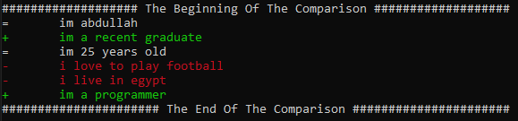

2.0 PROGRAM FLOWCHART:

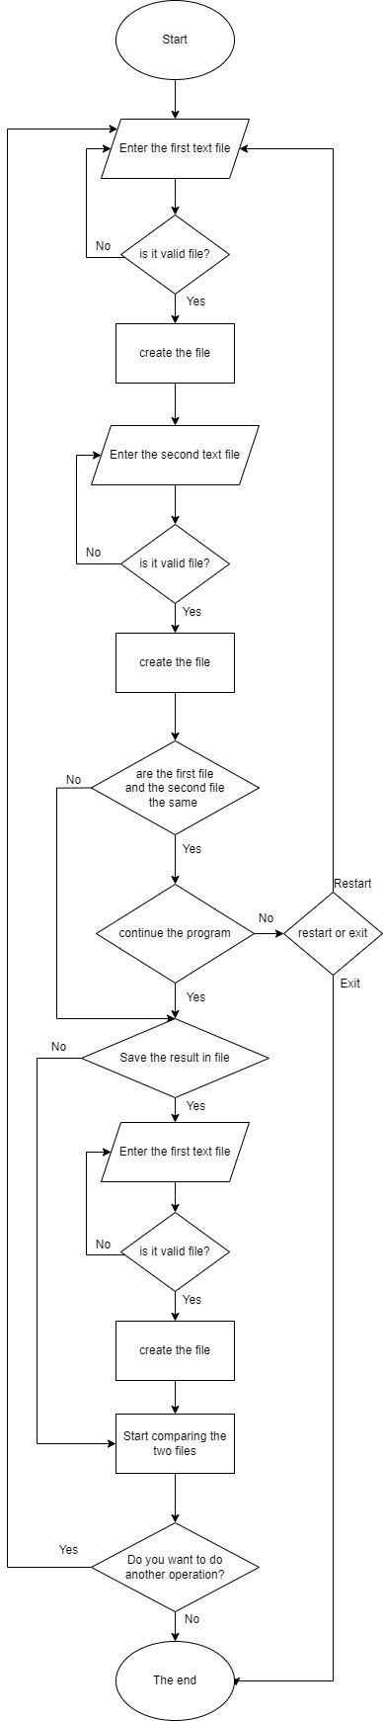

3.0 TESTING STRATEGY

First, apply alpha testing (Unit testing) for each unit to ensure that all units work correctly and deliver the expected output.

Directory:

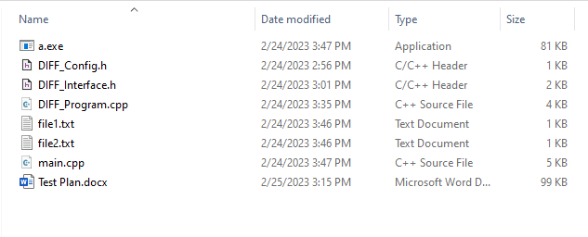

3.1 Alpha Testing (Unit Testing)

This tool has 4 units to test:

1. bool OpenFile(fstream& _file_stream, string& _file_name, ios_base::openmode _mode);
2. void CloseFile(fstream& _file_stream);
3. inline bool GotoLine(fstream& _file_stream, unsigned int _num);
4. void CompFiles(fstream& _file1, fstream& _file2, fstream& _out_file);

3.1.1 OpenFile:  
  
prototype:   
bool OpenFile(fstream& _file_stream, string& _file_name, ios_base::openmode _mode);

Test cases:

|  |  |  |  |
| --- | --- | --- | --- |
| _file_stream | _file_name | Expected output | Expected terminal output |
| obj | file | false | ERROR: the file extension is invalid... |
| obj | .txt | false | ERROR: the file name is too short... |
| obj | file1.txt | true | INFO: The file is opened successfully... |

3.1.2 CloseFile:

prototype:   
void CloseFile(fstream& _file_stream);

Test cases:

|  |  |
| --- | --- |
| _file_stream | Expected terminal output |
| fstream without calling open() | INFO: The file was already colsed... |
| fstream after calling close() | INFO: The file was already colsed... |
| fstream after calling open() | INFO: The file is closed successfully... |

3.1.3 GotoLine:

prototype:   
inline bool GotoLine(fstream& _file_stream, unsigned int _num);

Test cases:

|  |  |  |
| --- | --- | --- |
| _file_stream | _num | Expected output |
| File has 5 lines | 1 | true |
| File has 5 lines | 5 | true |
| File has 5 lines | 5< | false |

3.1.4 CompFiles:  
prototype:   
void CompFiles(fstream& _file1, fstream& _file2, fstream& _out_file);

Test cases:

|  |  |  |
| --- | --- | --- |
| _file1 | _file2 | Expected terminal output |
| im abdullah  im 25 years old  i love to play football  i live in egypt | im abdullah  im a recent graduate  im 25 years old  im a programmer | = im abdullah  + im a recent graduate  = im 25 years old  - i love to play football  - i live in egypt  + im a programmer |
| im abdullah  im 25 years old  i love to play football  i live in egypt |  | - im abdullah  - im 25 years old  - i love to play football  - i live in egypt |
|  | im abdullah  im a recent graduate  im 25 years old  im a programmer | + im abdullah  + im a recent graduate  + im 25 years old  + im a programmer |
| im abdullah  im 25 years old | im abdullah  im 25 years old | = im abdullah  +  = im 25 years old |

3.2 System and Integration Testing

Input text files:

|  |  |
| --- | --- |
| file1.txt | file2.txt |
| im abdullah  im 25 years old | im abdullah  im 25 years old |

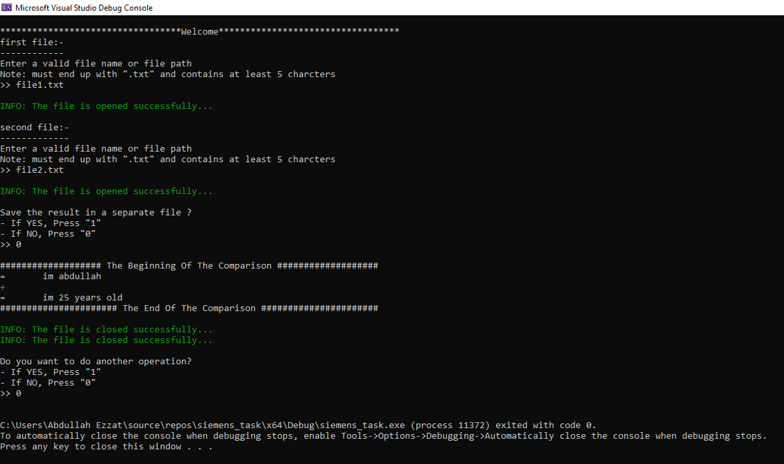System test case #1:

|  |  |  |
| --- | --- | --- |
| Question | User input | Expected terminal output/Action |
| first file:-  ------------  Enter a valid file name or file path  Note: must end up with ".txt" and contains at least 5 charcters | File1.txt | INFO: The file is opened successfully... |
| second file:-  ------------  Enter a valid file name or file path  Note: must end up with ".txt" and contains at least 5 charcters | File2.txt | INFO: The file is opened successfully... |
| Save the result in a separate file ?  - If YES, Press "1"  - If NO, Press "0" | 0 | The results show up |
| Do you want to do another operation?  - If YES, Press "1"  - If NO, Press "0" | 0 | The program exits |
| 1 | The program starts again |

System test case #2:

|  |  |  |
| --- | --- | --- |
| Question | User input | Expected terminal output/Action |
| first file:-  ------------  Enter a valid file name or file path  Note: must end up with ".txt" and contains at least 5 charcters | File1.txt | INFO: The file is opened successfully... |
| second file:-  ------------  Enter a valid file name or file path  Note: must end up with ".txt" and contains at least 5 charcters | File1.txt | INFO: The file is opened successfully... |
| WARNING: The two files are the same...!  - To continue, Press "1"  - To restart the program, Press "2"  - To exit the program, Press "3" | 1 | The program continues normally like test case #1 |
| 2 | The program starts from the beginning |
| 3 | The program ends |
| O.W. | ERROR: Invalid choice... |

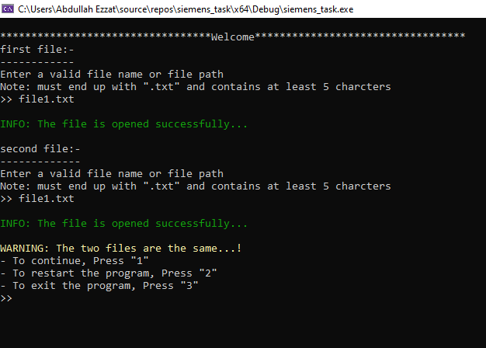

System test case #3:

|  |  |  |  |
| --- | --- | --- | --- |
| Question | User input | Expected terminal output/Action | |
| first file:-  ------------  Enter a valid file name or file path  Note: must end up with ".txt" and contains at least 5 charcters | File1.txt | INFO: The file is opened successfully... | |
| second file:-  ------------  Enter a valid file name or file path  Note: must end up with ".txt" and contains at least 5 charcters | File2.txt | INFO: The file is opened successfully... | |
| Note: If you entered one of the two input files, the data will be removed before the comparison...  Enter a valid file name or file path  Note: must end up with ".txt" and contains at least 5 charcters | File3.txt | INFO: The file is opened successfully... | |
| The program creates file3.txt.  The results show up. The program saves the results in file3.txt. | |
| Do you want to do another operation?  - If YES, Press "1"  - If NO, Press "0" | 0 | | The program exits |
| 1 | | The program starts again |

